Data science methodology overview from John Rollins
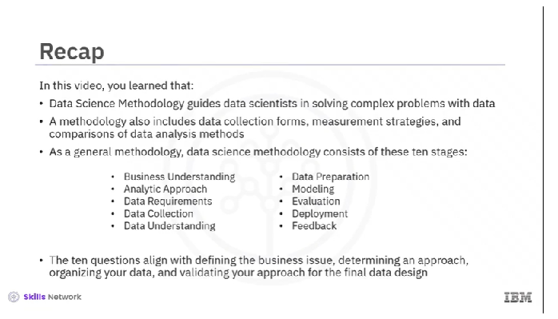

- Business Understanding

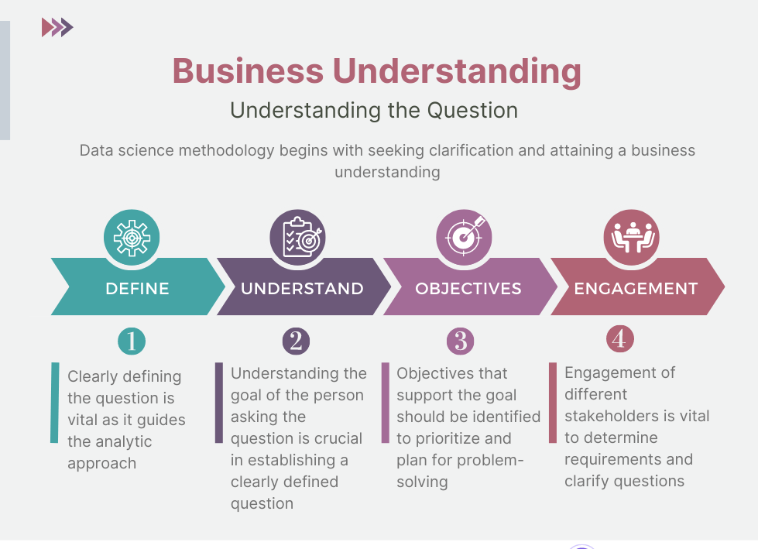
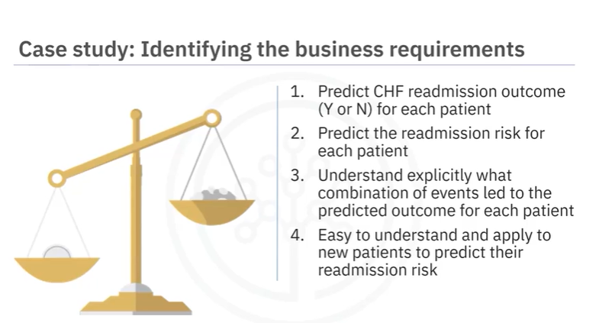

Analytic Approach

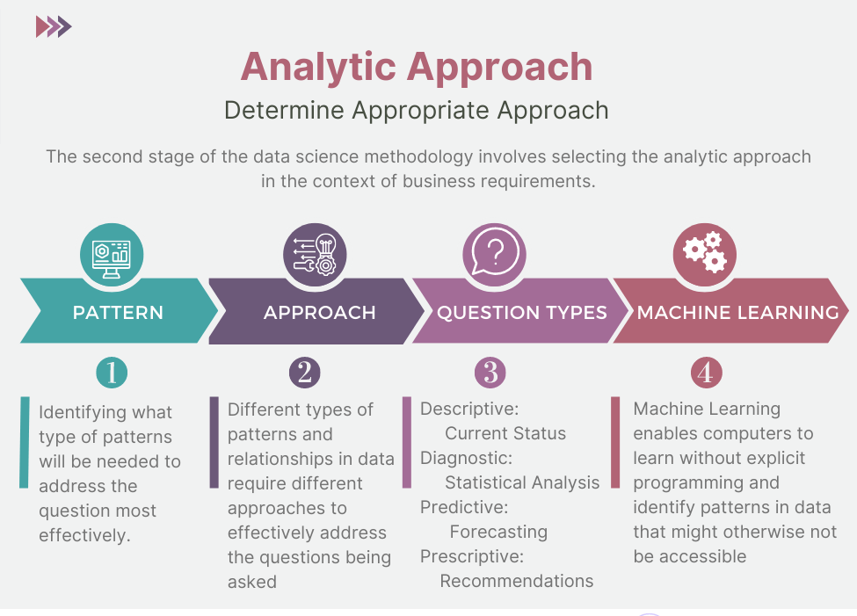

Data Requirements and Collection
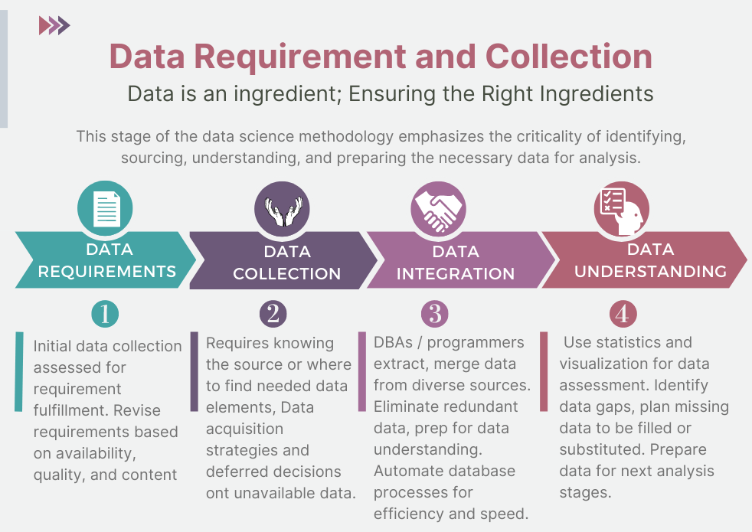

Data Understanding and Preparation
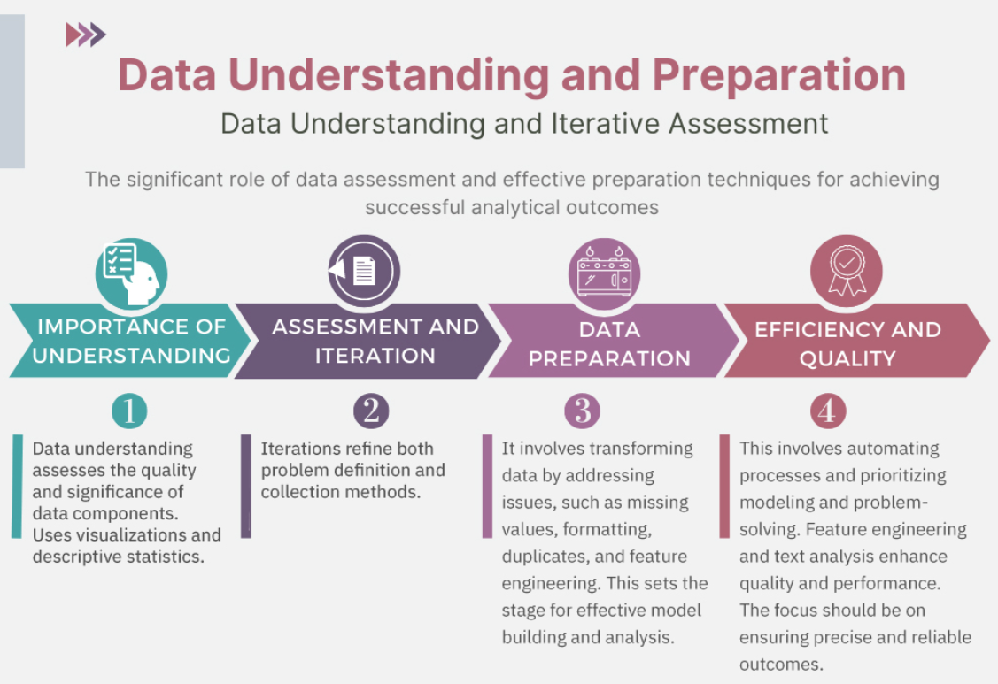

The data understanding stage encompasses all activities related to constructing the dataset and answers the question of whether the data you collected represents the problem to be solved. During the data understanding stage, scientists might use descriptive statistics, predictive statistics, or both. Data scientists commonly apply Hurst, univariates, and other statistics on each variable, such as mean, median, minimum, maximum, standard deviation, pairwise correlation, and histograms. Data scientists also use univariates, statistics, and histograms to assess data quality.
During the data preparation stage, data scientists must address missing or invalid values, remove duplicates, and validate that the data is properly formatted. Feature engineering, also part of the data preparation stage, uses domain knowledge of the data to create features that make the machine learning algorithms work. For example, a data scientist working on the prediction of property prices would calculate the age of a property by subtracting the “year built” from the current year, in order to get the value for the variable “age of house”. This variable would enhance the model’s predictive ability. Text analysis during the data preparation stage is critical for validating that the proper groupings are set and that the programming is not overlooking hidden data.
Data Modeling to Evaluation

The end goal of the modeling stage is that the data model answers the business question.
The data modeling process uses a training data set. Data scientists test multiple algorithms on the training set data to determine whether the variables are required and whether the data supports answering the business question. The outcome of those models is either descriptive or predictive.
The evaluation phase consists of two stages, the diagnostic measures phase and the statistical significance phase. During the evaluation stage, data scientists and others assess the quality of the model and determine if the model answers the initial business understanding question or if the data model needs adjustment. The ROC curve is a useful diagnostic tool for determining the optimal classification model. This curve quantifies how well a binary classification model performs, declassifying the yes and no outcomes when some discrimination criterion is varied.

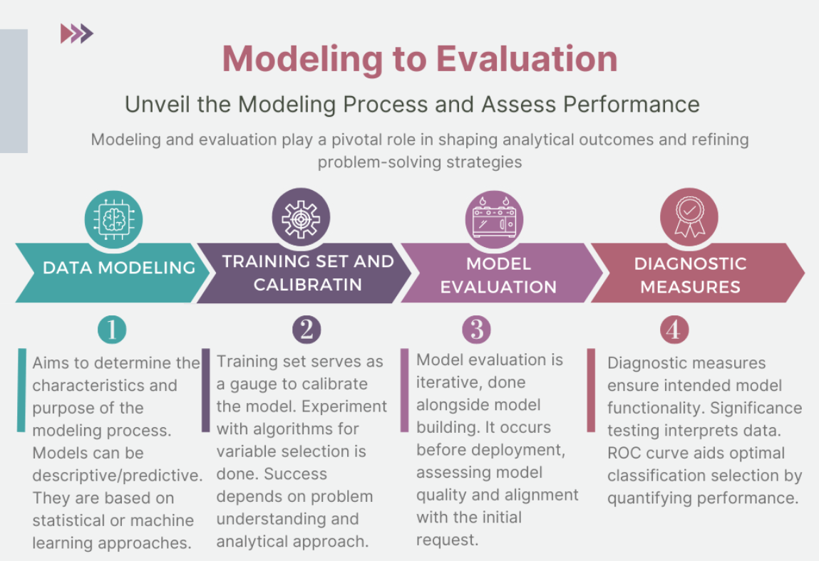

Model Deployment and Feedback

Stakeholders, including the solution owner, marketing staff, application developers, and IT administration, evaluate the model and contribute feedback. During the deployment stage, data scientists release the data model to a targeted group of stakeholders. Stakeholder and user feedback help assess the model's performance and impact during the feedback stage. The model's value depends on iteration; that is, how successfully the data model incorporates user feedback. The deployment, feedback, and redeployment process and phases are outlined in the infographic below.

